1. Playbook

Overture:

User begins in a room with 6 figures.  
The user is launched into space travel (think Star Wars) and is transported into a falling sequence.

VR reality:

From the falling sequence the user is presented a blank void with a single door at its centre.  
When user enters the door they are presented with a hallway containing a series of doors.   
When the user enters the different rooms in the hallway, they are presented with spaces that are themed around different art media.   
In each room the user will be prompted to collect an object symbolic of the media.  
When the user takes the symbolic object the space starts to degrade or be destroyed, prompting the user to leave.  
The user then brings the symbolic object back to the white void.   
When the user places the symbolic object in the void space, imagery or objects representing the specific media appear in the space.

The user continues to explore the rooms in the hallway, adding to the void bit by bit.

Ending:

Hey Simon, I wasn’t there the day you guys settled on this concept did you decide on a specific ending? Not for the prototype but the full future experience?

Honestly, I believe we never fully settled on that because of the shift in focus towards the playable prototype. It would have been preferable to organically work towards finding out together what makes VR unique to us, i.e. a satisfying conclusion (embodied escapism?), but the way this whole class was structured didn’t really allow that kind of work-through-process type of artistic approach.

For the true ending we only ever got to the point of having them fully rebuilding, layer by layer the beginning space travel, eye of the universe moment where the experience was glitched and put on hold. Through all the growing imagery (handwriting, brush marks, nature growing) they would create themselves in the virtual space, more and more of the aforementioned recognisable would start bleeding back in. The blank space itself being the ‘elevator’ they feed creative power to, to take them back up, through the different strata, out of the rabbit hole.

Once ‘circled back’ the black hole would suck out all their VR creations, as well as the 6 overzealous voyagers/artists, blink out of existence and deliver the user back onto their own reality. Absolving the latter of their transgressions and sending them on their way with (probably) more questions than answers.

However, since the project will probably never actually develop any further, this might be a good part in the document to really go all out and dream up a more imaginative, wild, spiritual or even personal climax. If you think that would add anything... maybe deepen the emotional investment through having them creating a living being in the VR realm that they would then inevitably have to leave behind to their own devices. Having them climb a mountain and then seeing a skyline of ever more towering climbs, to bring home the metaphor of there always being another one to climb in this endeavour of art-making.

1. Visual Storyboards

I’m gonna do some nice charcoal sketches this weekend, so we have something nicer than what I did for the production plan

1. Prototype Story Structure

Script for playable teaser  
  
What follows is the scenario for the sequence we feel is most achievable to deliver as the prototype given the deadline. Our goal is to give a vertical slice of what the totality would entail, by emphasizing the beginning being the portal itself, fully working out at least one exemplifying “resident” room, suggesting further possibilities and offering an abbreviated version to arrive at a would-be ending.

Ouverture   
  
Our troupe, in cult like character, guides the willing user into the black box VR experience. Giving them the rundown of what -supposedly- is about to unfold.

We’re in need of a seventh traveler to take us to a realm unknown.

Departure   
  
Once initialization of the user is complete (/ goggles on), the room becomes a facsimile of itself within the headset. Us included. The real us gradually disappearing to leave the user to their own devices, monitoring their experience from without. Our models put on their headsets to commence the ritual, flip the switch. The smoke and mirrors space light show expands before their eyes. Lights and laser lines mapping out an interstellar atlas they can lose themselves in.

These theatrics give our doppelgängers ample time to enact their true intentions: a sacrificial offering to incite an event horizon. Surrounding the user whilst a leader counts them down, they summon the desired black hole portal. Their gate to a new, higher plane of existence.

Fallen down the rabbit hole  
  
As the black hole descents and threatens to swallow the environment as well as everyone in it, a glitch in the program occurs. Freezing the proceedings, corrupted artefacts strewn about, whilst saving the user from the precarious situation by making the simulated floor drop out. Sending them hurtling ever downward, out of bounds, through the fabric of that artificial world. Within the mechanics of the Technology.

Sights, sounds and rushing pov-camera movement are all subject to gravity and help instil the butterflies/ ‘G-Force’ sinking feeling. Gradually giving way to a never ending abyss, the user suspended in meaningless vertical motion.

Onto Blank Space  
  
Until, within the blink of an eye, the user makes impact with bedrock, as they are deposited onto a monolithic slab hanging in boundless white void. Blank space, VR’s equivalent to a blank page or canvas. A daunting task now hanging over them: Create your way back home. How they get to achieve this will be the trial run of the following segments.

Initiation  
  
After a set amount of time being turned around and shifting their view, the simulacrum of a stage door appears behind them. Locked. Following the sound of jangling metal leads the now engaged actor to perceive the needed key dangling mid-fall in the middle of blank space. As the user interacts with the object (think of Alice’s eat me/drink me scene), the surrounding sound of banging on the other side of the door goes off. It isn’t until the agent -now able to unlock- opens the wooden gate onto a hotel-like hallway hub of doors, that the threatening audio stops.

This dreamlike tutorial is meant to instill a more intuitive way of feeling out the workings of the space they have found themselves in.

Once in the corridor a similar occurrence (sound and light) guides them, past other non-interact able doors all of which carry their own symbolic emblems, to the one that is slightly ajar. The one with the quill emblem. Crossing the threshold transports them to the first ‘resident’ scene.

The Writer’s cellar (door#1)  
  
The scene opens up within the cellar hideaway of a possessive writer. Moldy walls and ceiling plastered with notes and manuscripts, dog eared annotated paperbacks covering the rotting hardwood floor, a window with a fake view, leaky pipes, long, wordy adjectives coupled with common nouns, the whole works! The clacking of a typewriter pervading the damp atmosphere and the emerald green desk lamp illuminating it draw the user’s attention. Once interacted with (pressing indicated keys) the light burns out, ink seeps through the pages on the wall and forms a tunnel out of discarded paper.

This leads the interacteur to the treasure room of the writer. A storage maze of cabinets filled to the brim with obsessively kept great novel ideas. At its heart the most precious possession beckons the user: the writer’s first ever story and the quill used to pen it when they were still a child. Navigating the maze with a constant feeling of being watched and ultimately picking this core up, the user inadvertently takes out the cornerstone of this place.

Return  
  
With narration now on their side the objective becomes clear: escape the deterioration! As now the rules of time and space are coming undone. The maze has expanded around them and the dark presence more actively lurks and stalks them throughout their way back. An inky fire starts spreading as an attempt to contain the thief.

Having made their escape, the last image they see are the pleading crumpled remains of the writer, before crossing the return threshold and coming out of the abstracted, surreal nightmare sequence.

Teleported back to the blank space. With the quill in their hand they can now begin writing to fill it in. I.e. place the quill like a puzzle piece into the holder on a suddenly resurfaced desk on which the typewriter now manifests itself. The element of storytelling has been regained.

If the technology allows it we’d set up a system that translates their handwritten marks and/ or typing into physically present text in the otherwise blank environment. The same would apply for the paint brush, the instrument/conductor’s baton, the lay figure body, the camera, time; all tools that in some way could influence and cover the canvas of the void.

This process of finding a core element, taking it back and using it to further fill out the vr-space is the main crux of our experience. To present as tangible the different artistic threads that facilitate immersive storytelling in virtual reality.

An imposter’s ending  
  
We would like to at least offer a taste of what these cumulative threads could be, which is why (after going through the above mentioned events) if you knock on the other emblematic doors a short snippet of visuals, sounds and spaces would blast through the headset. Each giving a teaser of the represented artistic branch behind the emblem (writer, painter, composer, choreographer, director, horticulturist).

To finish up the demo as well as to close the hero’s journey loop, we would formulate an abbreviation of further events to skip the user forward and lift them back up to the surface world. Out of the rabbit hole. By collecting a letter dropped at the end of the hotel hallway, the engaged actor receives personalized instructions on how to return. (If the technology allows it) They have to handwrite/type “FIN/take me home” in the blank space, at which point an elevator appears. Ascending with said elevator sees the interacteur cut through all the different strata of the experience one final time. Leaving behind the mirage of a completed oeuvre.

Upon reentry in the same room & position as where their voyage began, our troupe would debrief and re-acclimatize the user to the real world (/goggles off). Claiming that the latter had suddenly vanished while the rest of them were stuck in the launch sequence. Better luck next time…

1. 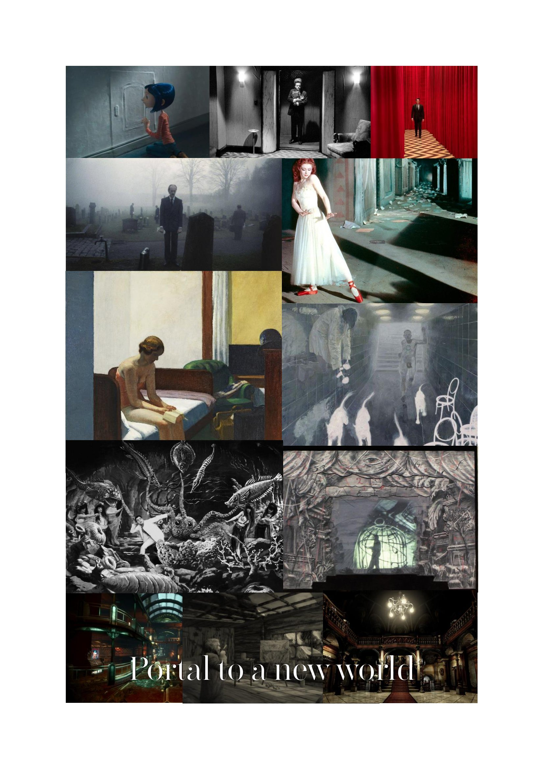Mood board

Simon’s preliminary sketches

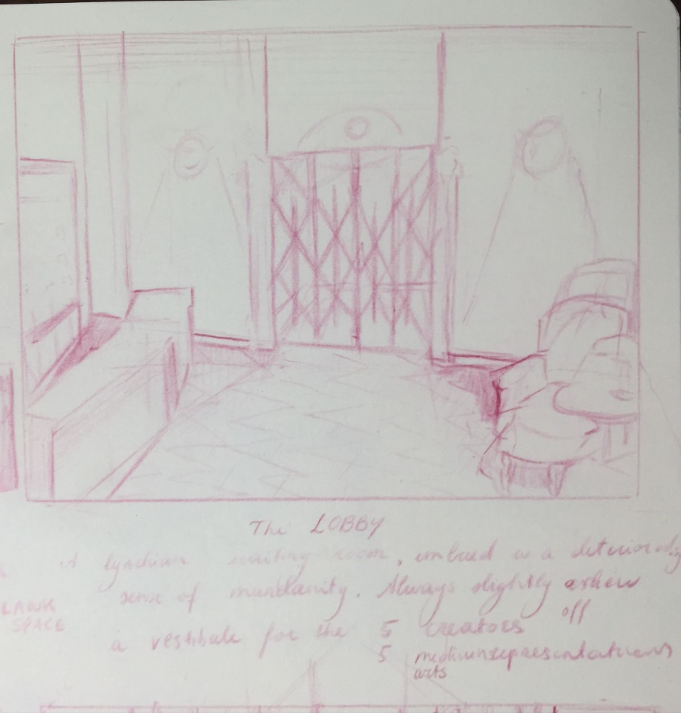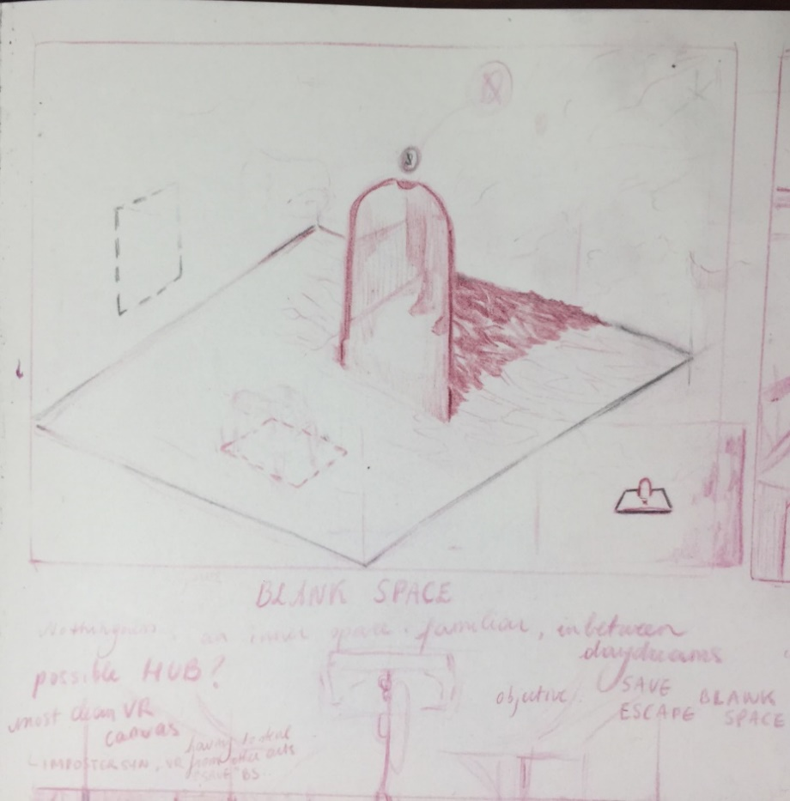

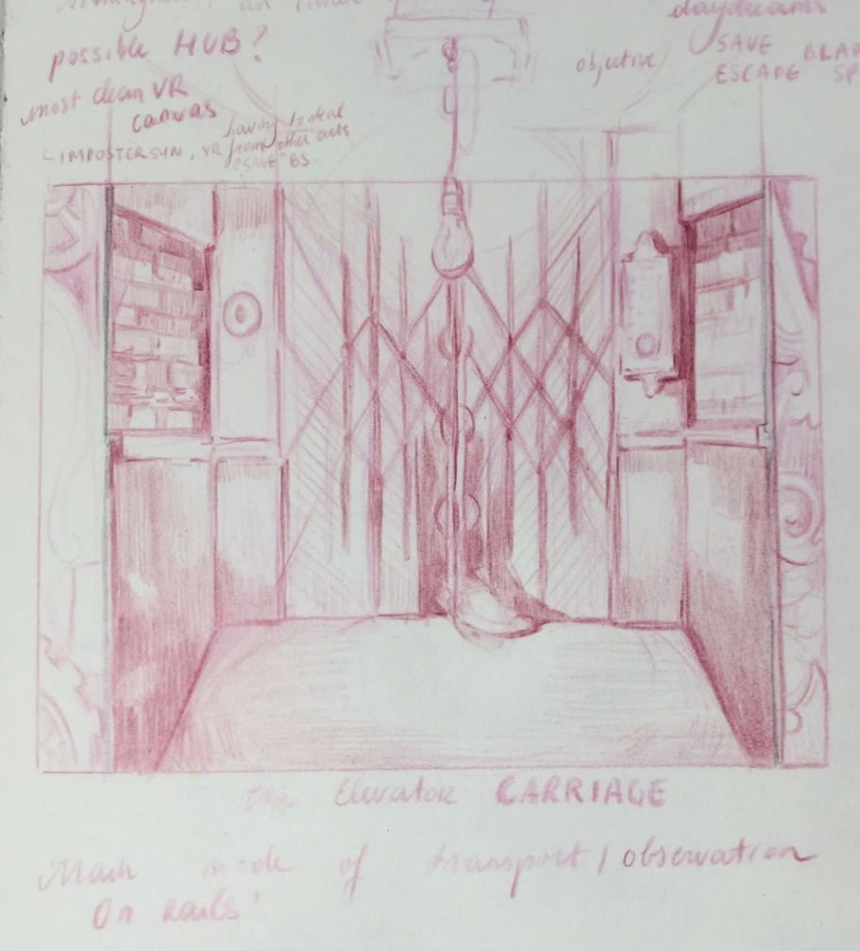

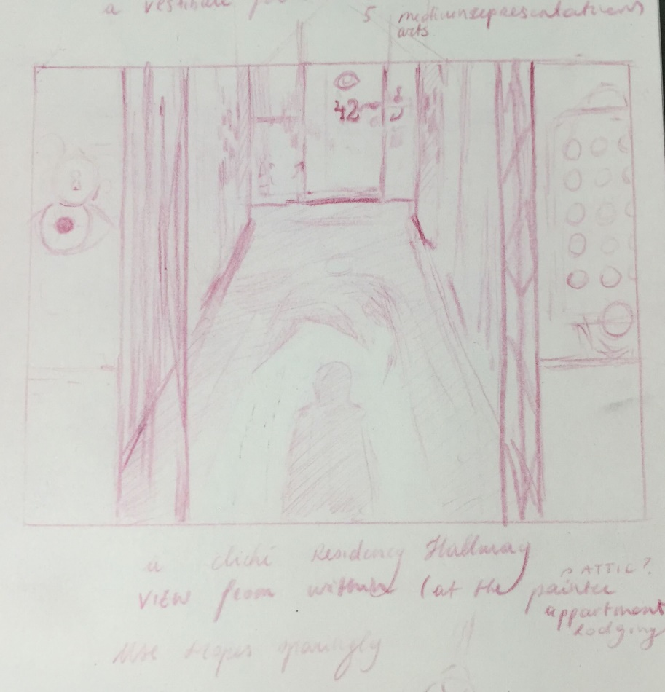

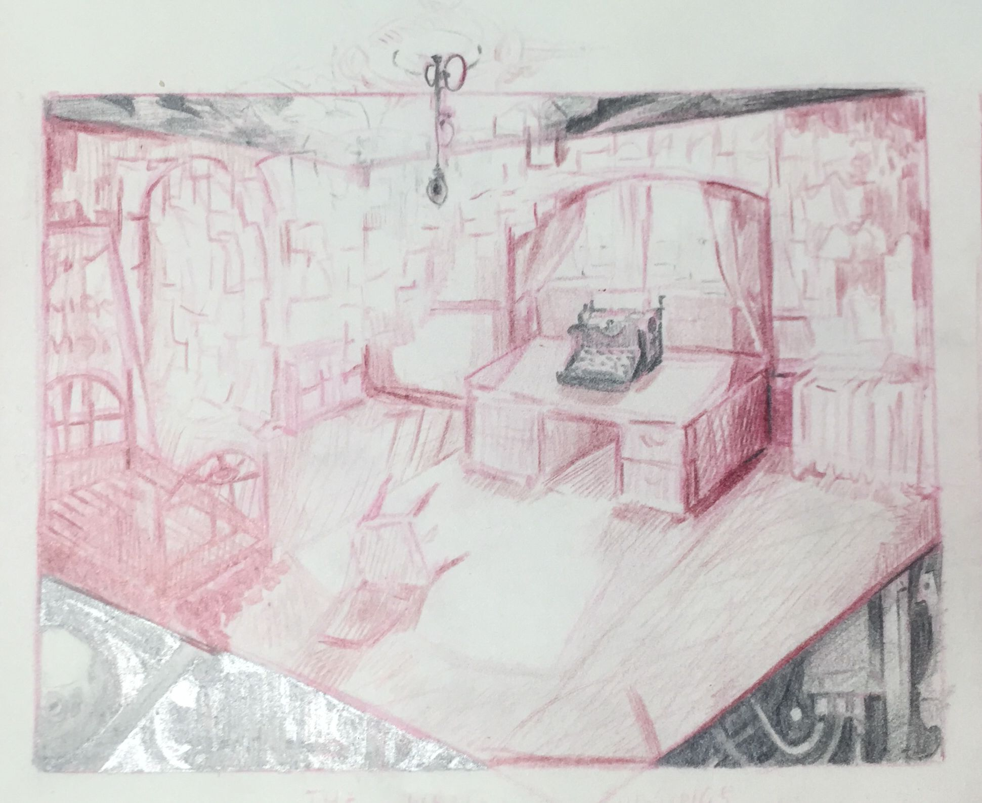

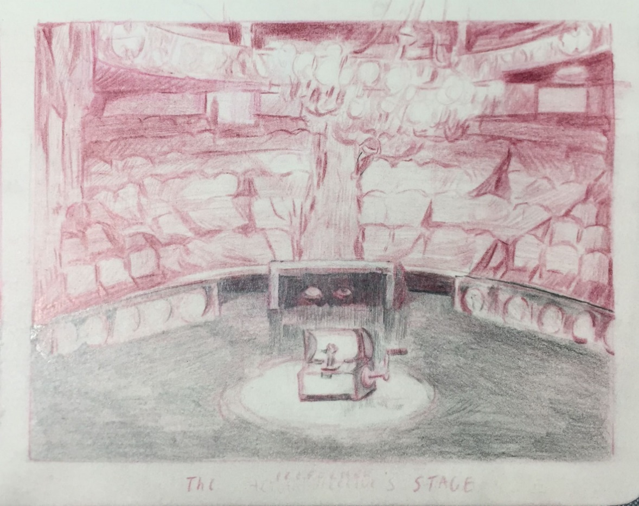

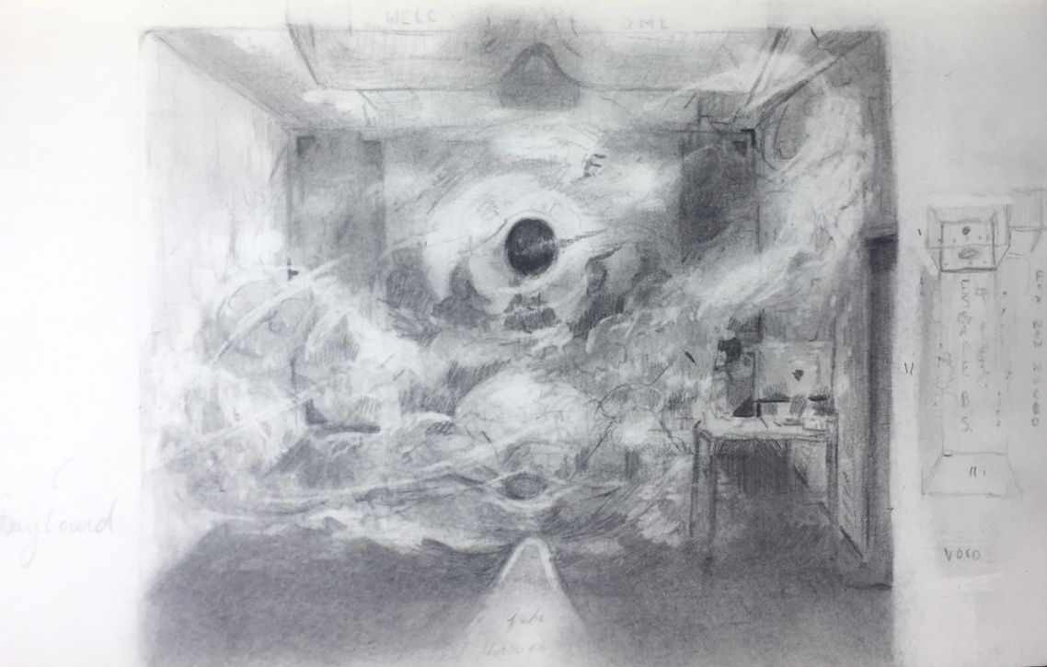

1. User Flow

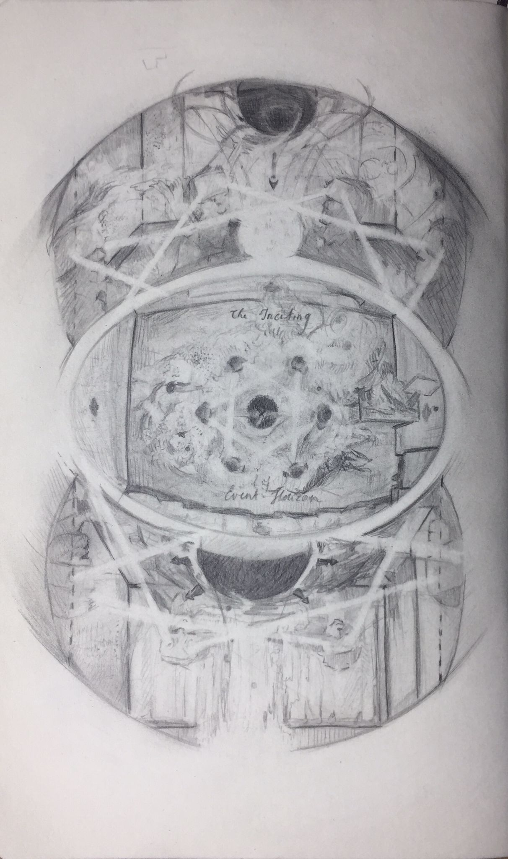

Figure 1 Simon's visual conception of the user flow

The user flow could be described as circular. After the ‘overture’ , the user is prompted to follow a sequence in which they begin at the void, continue to a room and return with the symbolic object to the void and then begin the cycle again. We hope that with the creative, gamified aspect and the degradation of the rooms will be sufficient to prompt the user to continue their journey.

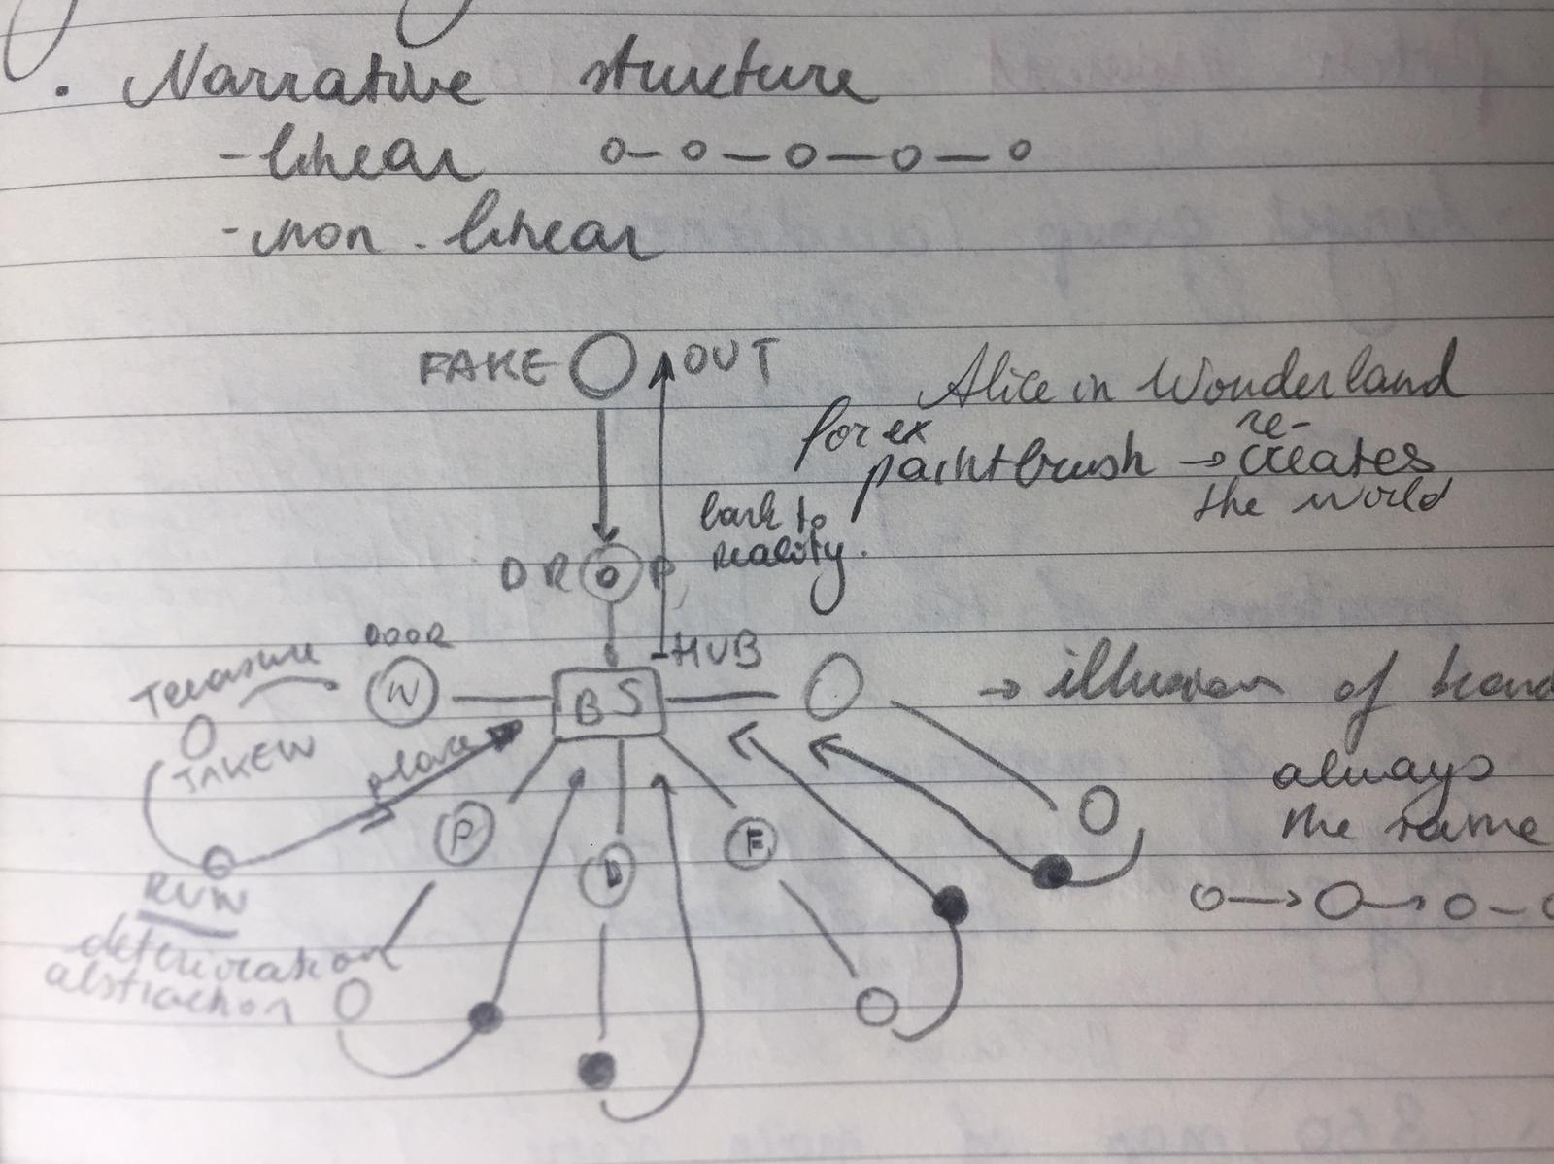

Figure 2 Diagram of user flow

1. Conceptualisation – did my best here, there is probably more that you can add. Feel free!

When we began working on this project, we were very inspired by various films and video games. We had imagined a user exploring a haunted hotel. The point was raised that this conception did not entirely fit the brief, there was no portal element and no real novelty in the environment and aesthetics.

Through discussion we came to the conclusion that allowing the user to create an environment would be better aligned with the idea of a new world. It was posited that VR could be seen as a medium that builds on and integrates previous art movements. To underpin this concept the user would be allowed to literally build with previous art forms, by bringing the symbolic objects back to the void.

A decision was also made to add a literal portal during the overture stage of the work. Beginning with the framing device underpins the original prompt and allows the user to experience a total shift from the real world.

1. Additional original artwork

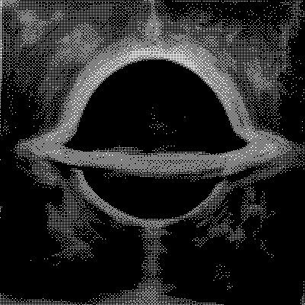

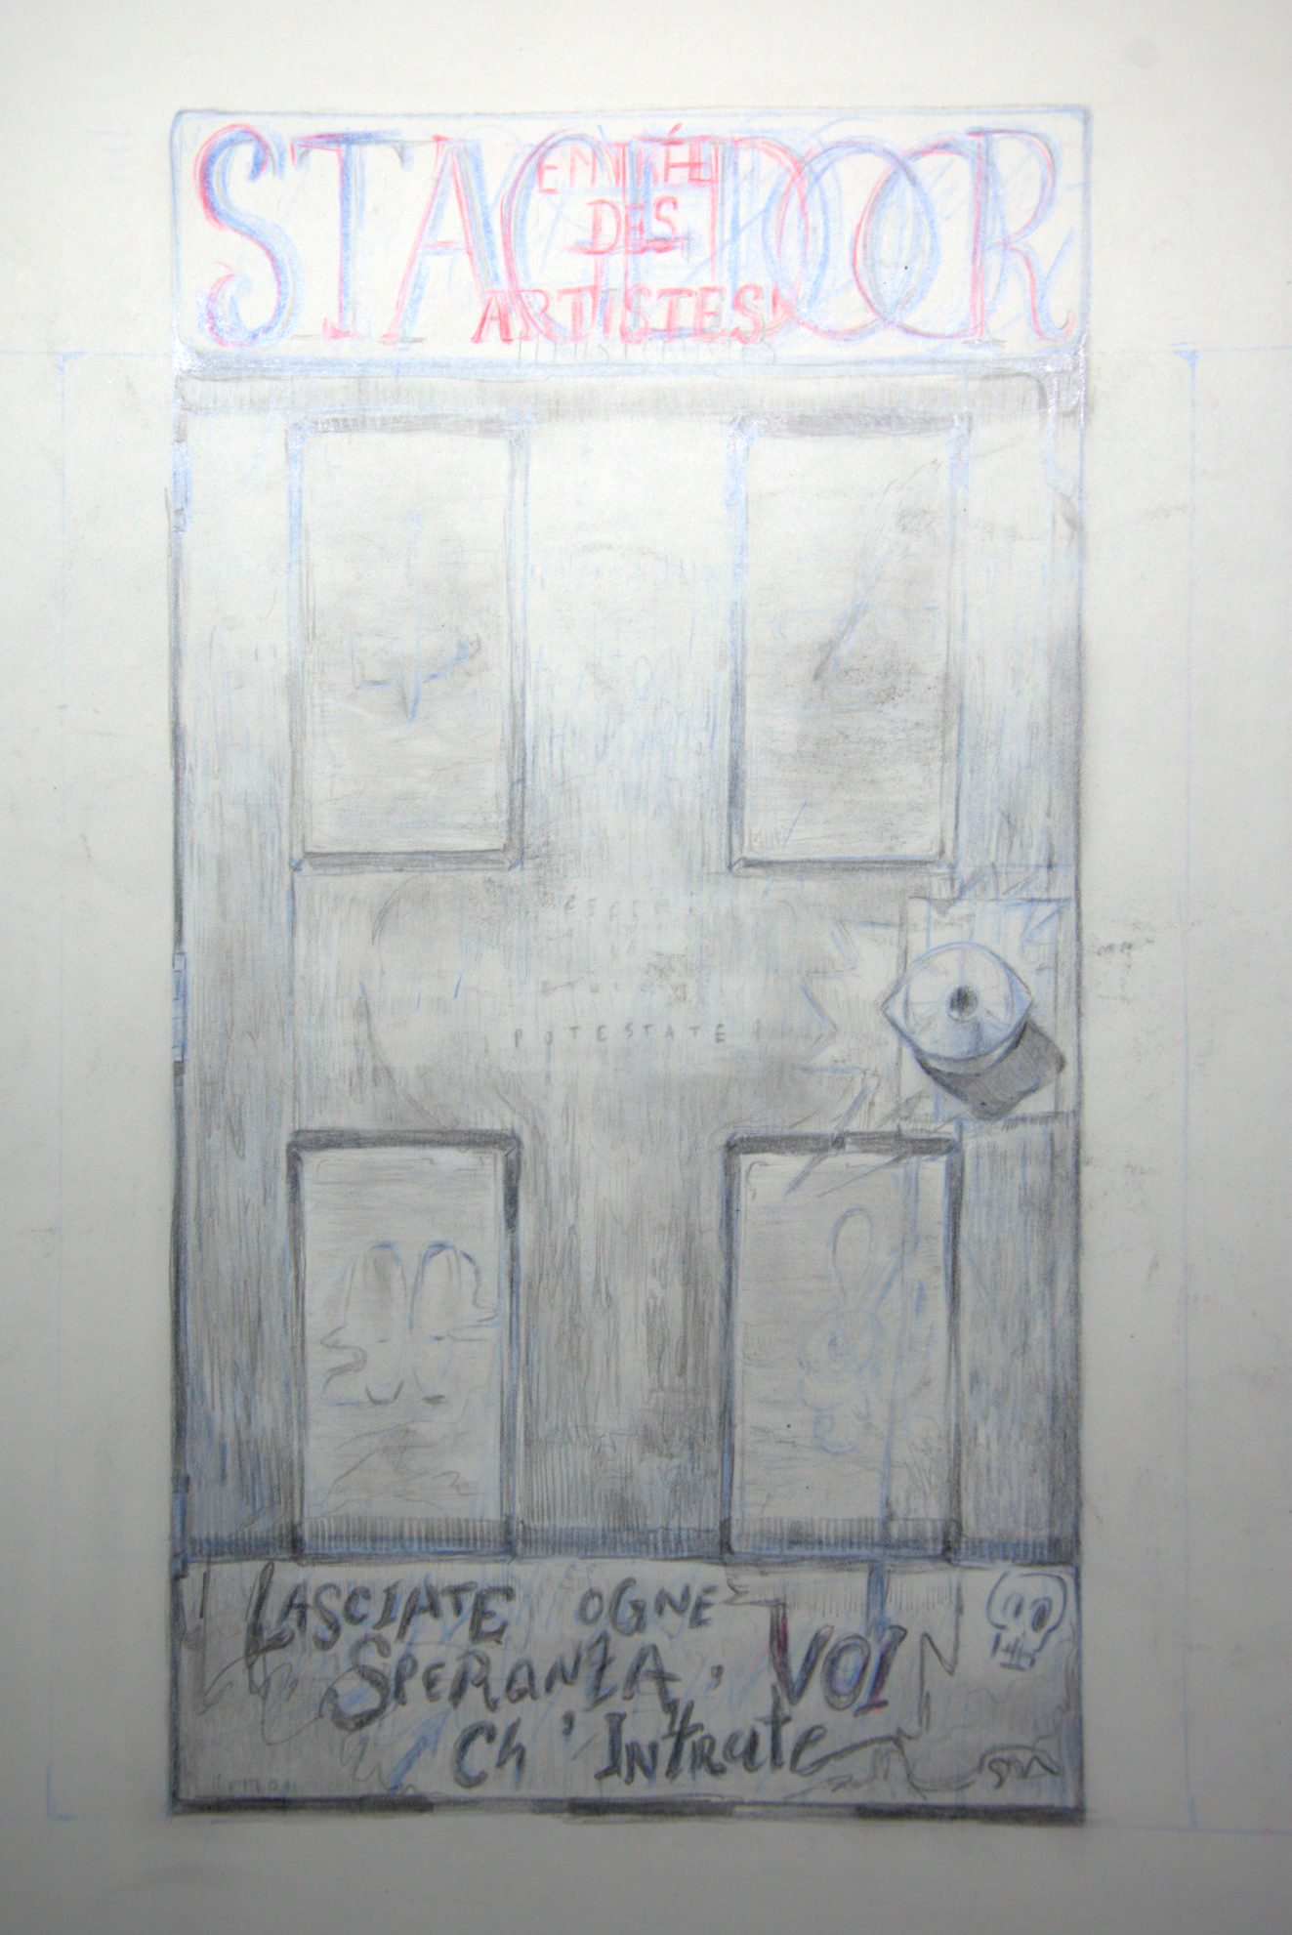

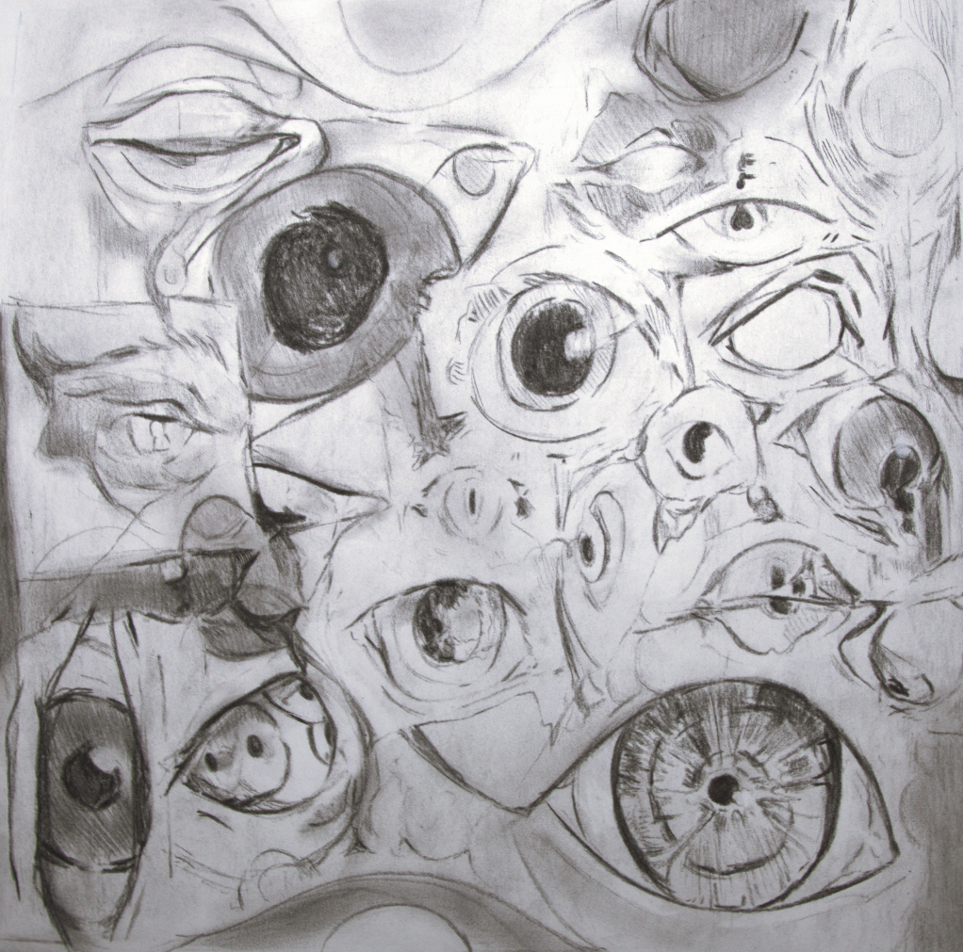

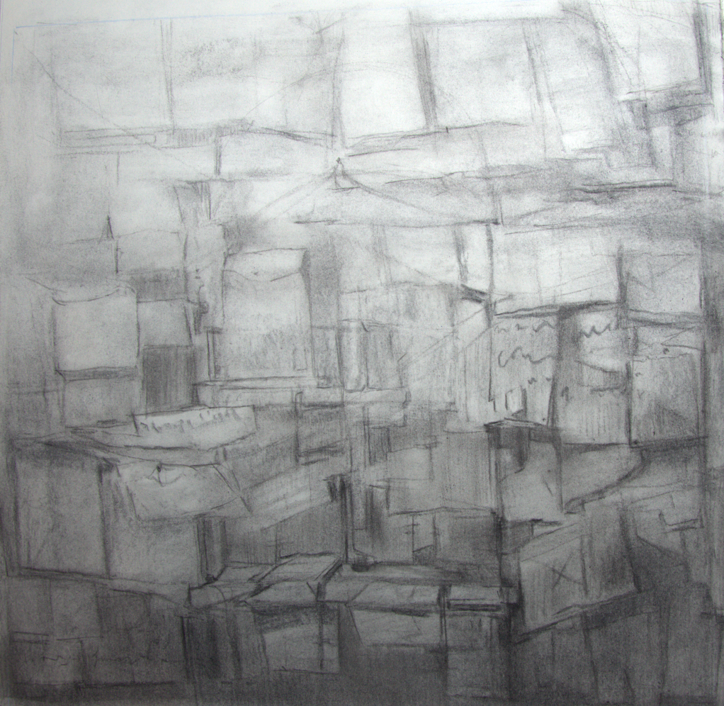

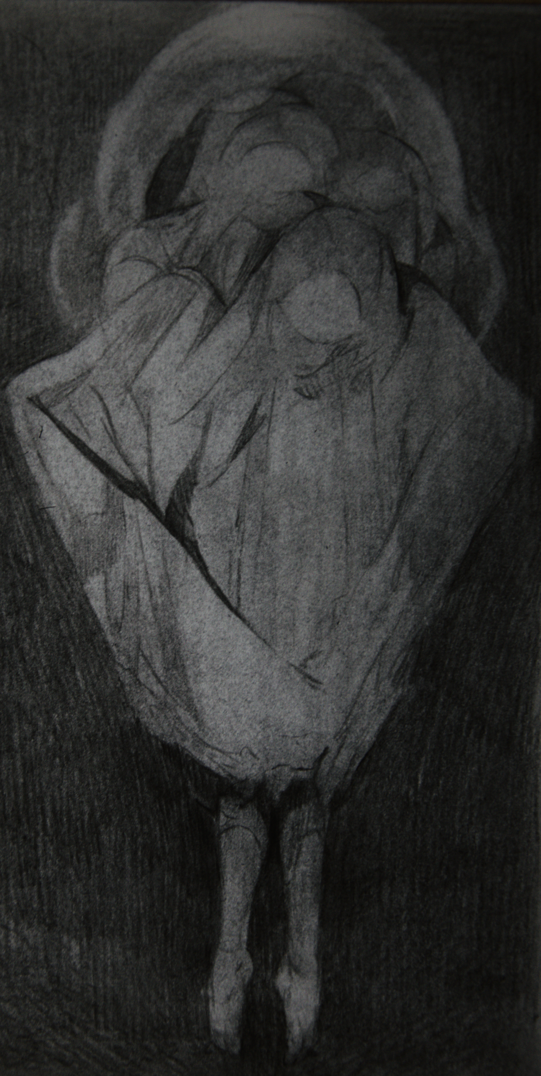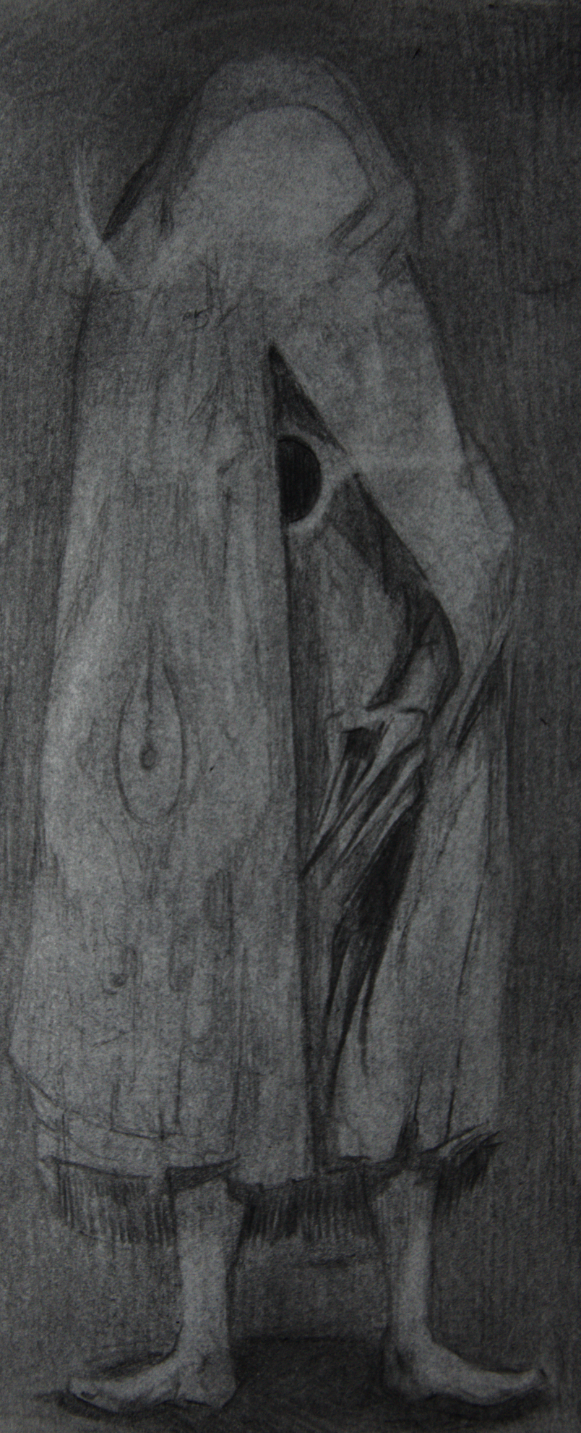

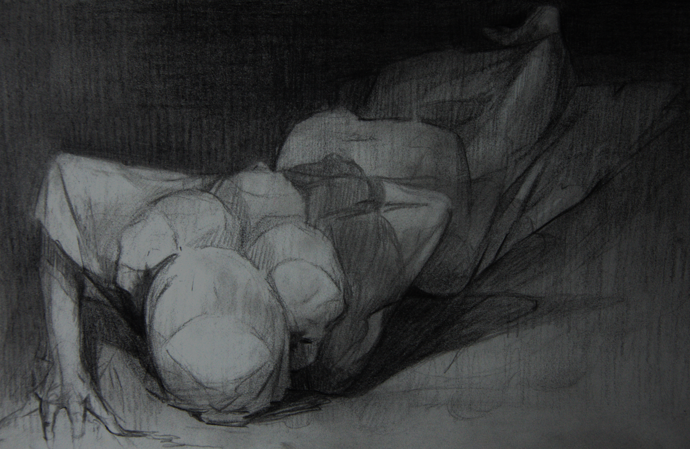

1. Music/SFX Rundown

**Black Hole**

MUSIC: Track 1 Loop (PTANW Ouverture)

SFX:

* Metronome [softly underlying]
* Black Hole Static [when it appears]

**Falling**

MUSIC: Falling 1   
SFX:

* Skydive
* Rush
* Water Impact [the moment they hit the blank space ground]

**Blank Space**

MUSIC: N.A.   
SFX:

* Lightbulb Hum [on loop, gradually increasing until;]
* Knock Knock Knocking on Wood [linked to the stagedoor showing up]
* Key [once the key drops behind the interacteur]
* Wind-up Clockwork [key rotating in lock]
* Sliding Door [door opening]

**1st Hallway Intermission**

MUSIC: Full Track Loop 2 (The Writer) [with audio effect of being played in a different room] SFX:

* Metronome
* Wind-up Clockwork
* Pencil & Typewriter sounds [coming from beyond the first door]
* Cathedral Entrance [opening the door]

**Writer’s Room**

MUSIC: Full Track Loop 2 (The Writer)  
 [linked to the pencil, a radius that gets more overwhelming the closer the user gets to the centre] SFX:

* Ancient Typewriter (the keys)/Decisive Pencil Drawing [trail towards the pencil]
* Pullback Typewriter [taking the wrong turn]
* Metronome ambiance

Pencil Pick-up:

* Antique Chimes [louder and louder as they make their way back]
* Paper Pencil
* Library Quake [once book cases rearrange + screen shake]
* Cathedral Entrance [sped up, to simulate effect of slamming door shut]

? Presence ?

**2nd Hallway Intermission**

MUSIC: Music Box (The Performer) [coming from the theatre doorway] SFX:

* Cathedral Entrance [second door]
* Pencil Sharpener [Lock next to second door]
* Orchestra [as the interacteur goes through the vestibule]

**Stage Fright**

MUSIC: Music Box (The Performer)   
SFX:

* Spotlight [as they enter the theatre]
* [focus on the Music]
* Wind-up Clockwork [softly, to add to the music box]
* Whispers [Pick-up, and momentary darkness?]
* Spotlight reprise [Light on the crowd]
* Laughter & Clapping

**IMPOSTER RETURN**

MUSIC: Falling 1

SFX:

* Elevator
* Rush in reverse

? Maybe a collapse of all different sound effects as they make their way back to blank space; the place crashing in on itself?